|  |
| --- |
| ***A Mini Project Report on***  **IV DRIP LEVEL MONITORING SYSTEM**  **T.E. - I.T Engineering**  **Submitted By**  **Akshata Nalavade 21104003**  **Manjiri Gole 21104006**  **Shweta Bhutada 21104007**  **Vedanti Nandvikar 21104024**  **Under The Guidance Of**  **Ms. Charul Singh**    **DEPARTMENT OF INFORMATION TECHNOLOGY**  A.P. SHAH INSTITUTE OF TECHNOLOGY  G.B. Road, Kasarvadavali, Thane (W), Mumbai-400615  UNIVERSITY OF MUMBAI  **Academic year : 2023-24** |

|  |
| --- |
| **CERTIFICATE**    This to certify that the Mini Project report on **IV Drip Level monitoring System** has been submitted by **Akshata Nalavade (21104003), Manjiri Gole (21104006), Shweta Bhutada (21104007), Vedanti Nandvikar (21104024)** who are a bonafide students of A. P. Shah Institute of Technology, Thane, Mumbai, as a partial fulfilment of the requirement for the degree in **Information Technology**, during the academic year **2023-2024** in the satisfactory manner as per the curriculum laid down by University of Mumbai.    Ms. Charul Singh Dr. Kiran Deshpande  Subject Incharge HOD Information Technology |

|  |
| --- |
| **TABLE OF CONTENTS**   1. Introduction.......................................................................................................... 1 2. Review of Literature……………………………………………………………..2 3. Problem statement.................................................................................................4    1. Motivation.................................................................................................5    2. Objective.................................................................................................. 6 4. System Architecture..............................................................................................7 5. State Diagram/Workflow 6. Circuit Diagram 7. Project Timeline...................................................................................................10 8. Implementation…………………………………………………………………11 9. Hardware and Software requirements 10. Principle and working of project 11. Conclusion............................................................................................................ 16 12. Future Scope……………………………………………………………………..17 13. References |

**CHAPTER 1**

**Introduction**

In modern healthcare settings, the accurate monitoring and management of intravenous (IV) saline drip fluid levels are critical for ensuring patient safety and optimal treatment outcomes.  Conventional IV fluid level monitoring techniques frequently depend on healthcare staff observing patients by hand. This can be laborious, prone to human error, and cause delays in identifying and reacting to changes in fluid levels. To address these challenges, automated saline drip fluid level monitoring systems offer a promising solution.

Staff workload is another issue that manual IV system monitoring must deal with. Healthcare workers' workloads are increased by manual IV drip monitoring, especially in busy hospital settings where nurses and clinicians are already overworked. This could lower the standard of patient treatment, increase staff burnout, and also result in difficulty in proper documentation. When recording IV drip fluid levels manually, mistakes or omissions might happen, especially in hectic or stressful circumstances. The continuity of care may be impacted by inaccurate or inadequate recordkeeping, which could result in disparities in patient records.

With the help of automated IV drip monitoring We have increased accuracy by using sensor technology to precisely detect fluid levels, reducing the possibility of human mistake that comes with manual monitoring. This improves therapy efficacy and safety by guaranteeing that patients receive the appropriate dosage of medication or fluids. We can also implement continuous and real-time monitoring of fluid. It enables medical professionals to quickly identify and react to variations in fluid quantities or infusion rates. This makes it possible to take preventative measures and improve patient care.

IV drip systems can be programmed to generate alerts and alarms based on predefined thresholds or patient-specific parameters. This ensures timely notification of critical events, such as occlusions, air bubbles, or deviations from prescribed infusion rates, enabling rapid intervention and preventing potential complications. Advanced automated IV drip systems may incorporate adaptive control algorithms that dynamically adjust infusion rates based on real-time physiological parameters or feedback signals. This personalized approach to infusion therapy optimization can improve therapeutic outcomes and patient comfort while minimizing the risk of adverse events.

Automated saline drip fluid level monitoring systems utilize advanced sensor technologies, wireless connectivity, and data analytics to continuously monitor and track the levels of saline solution in IV drip chambers in real-time. These systems provide healthcare providers with accurate and timely information about fluid levels, enabling proactive interventions and enhancing patient care.

**CHAPTER 2**

**Review of Literature**

|  |  |  |  |  |  |  |
| --- | --- | --- | --- | --- | --- | --- |
| **Sr.no** | **Title** | **Author(s)** | **Year** | **Outcomes** | **Methodology** | **Result** |
| 1 | Monitoring of Intravenous Drip Rate | Vidyadhar V. Kamble, Prem C. Pandey, Chandrashekar P. Gadgil, and Dinesh S. Choudhary | 2021 | This system gave an perfect idea about the IV level present with the help of sensors. | Experimental | Automated IV drip monitoring and alerting system was successfully designed and implemented. |
| 2 | Intravenous Drip Monitoring System Using IOT | Sri Mathi V , Suganya MB , Sandhiya K , Nivetha D Assistant Professor Myilsamy G | 2021 | This system gave an perfect idea about the IV level present in the saline bottles with the help of GSM and other technologies. | Experimental | IV drip monitoring system using IOT was successfully developed. |
| 3 | IV Drip Monitoring and Control System | Sumalatha Bandari, Gauri Deshmukh, Pooja Pawar, Rutuja Yadav, Komal Jagadale, Dipti Chavan | 2021 | This system gave an perfect idea about the IV level present with the help of sensor and load cell displaying it on LED display and alerting the danger with the help of buzzer sensor. | Experimental | IV drip monitoring and alerting system using sensors was successfully designed and developed. |

## CHAPTER 3

## Problem Statement

Whenever there is a saline drip, there is a need for a person to monitor the glucose level and the glucose flow rate may be at regular intervals of time. The concerned patient should be in careful observation. The manual monitoring of saline levels in intravenous (IV) fluid bags poses significant challenges, including time-consuming tasks for healthcare staff, the risk of treatment interruptions, potential errors in fluid management, increased workload in hospital

### Motivation

### It is necessary to design a IV drip monitoring system as a mechanism to reduce the workload of hospital staff and enhance patient care and safety. The application of this proposed system is to remotely monitor and alert nurses about the current IV drip conditions by continuously measuring the IV level, and alerting the danger with the help of sound sensor(buzzer) and LED lights. The motivation for creating an automated drip IV system lies in the imperative to enhance patient safety, treatment accuracy, and healthcare efficiency. Manual management of intravenous (IV) drips is prone to errors, such as incorrect dosages, infusion rates, or missed monitoring of fluid levels, potentially leading to adverse events or compromised patient outcomes. By automating the control and monitoring of IV fluid delivery, automated drip IV systems reduce the likelihood of human errors, ensuring precise and consistent administration of medications, fluids, and nutrients.

### Objectives

* To design an automated IV drip monitoring system.
* To design a IV drip monitoring system using various technology/sensors.
* To monitor fall in the level of IV and alert the nursing staff.
* To reduce the workload for the hospital staff.
* To enhance patient safety and provide improved healthcare system.
* To provide an accurate and reliable monitoring system

## CHAPTER 4

## System Architecture

### State Diagram/Workflow

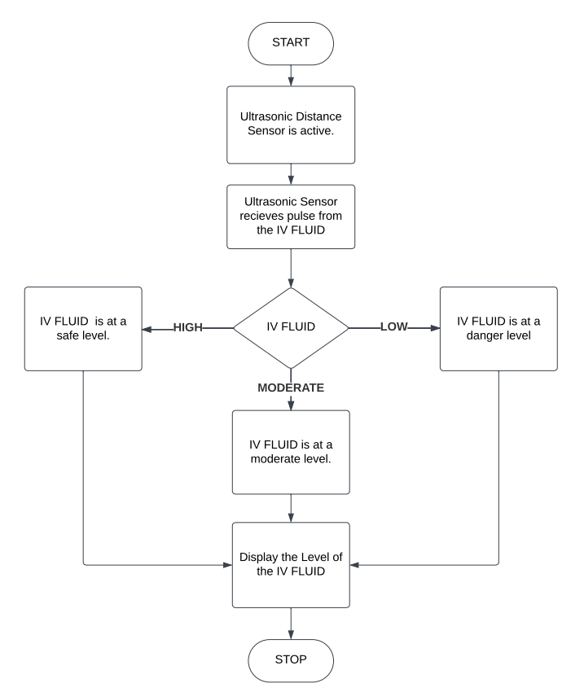

### Circuit Diagram

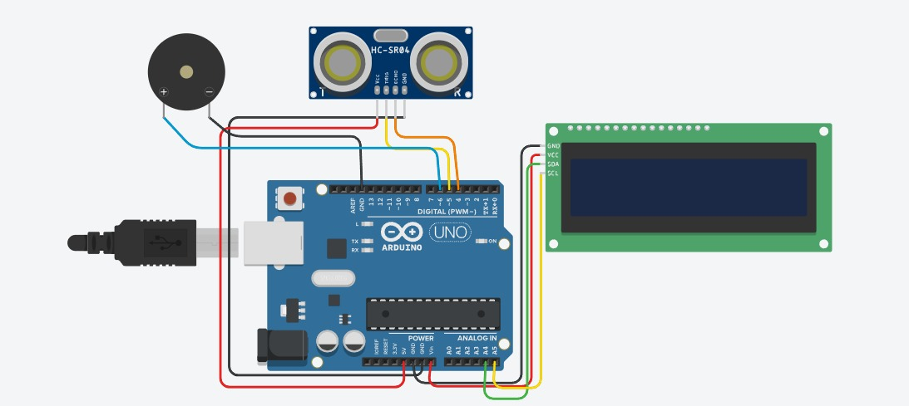

## CHAPTER 5

## Project Timeline

|  |  |  |  |
| --- | --- | --- | --- |
| **Sr.no** | **Group members** | **Time Duration** | **Work to be done** |
| 1 | Akshata Nalavade Manjiri Gole Shweta Bhutada  Vedanti Nandvikar | 3rd and 4th week of January. | Topic finalization and requirements gathering. |
| 2 | Akshata Nalavade Manjiri Gole Shweta Bhutada  Vedanti Nandvikar | 1st and 2nd week of February. | Implementing the circuit design on software. |
| 3 | Akshata Nalavade Manjiri Gole Shweta Bhutada  Vedanti Nandvikar | End of February and 1st week of March. | Connecting the components. |
| 4 | Akshata Nalavade Manjiri Gole Shweta Bhutada  Vedanti Nandvikar | By the end of March. | Final testing and resolving issues if any. |

## CHAPTER 6

## Implementation

### Hardware and Software Requirements

* Arduino UNO:

The Arduino Uno is an open-source microcontroller board based on the Microchip ATmega328P. It has 14 digital input/output pins (of which 6 can be used as PWM outputs), 6 analog inputs, a 16 MHz ceramic resonator, a USB connection, a power jack, an ICSP header and a reset button.

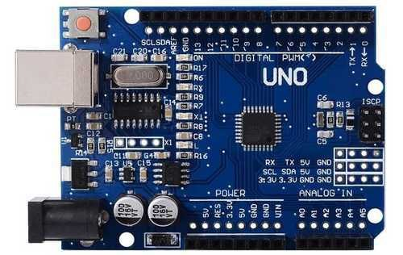

* Water level sensor/ HC-SR04 Ultrasonic sensor:

An ultrasonic sensor is an instrument that measures the distance to an object using ultrasonic sound waves. An ultrasonic sensor uses a transducer to send and receive ultrasonic pulses that relay back information about an object's proximity.

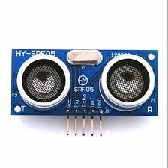

* 16 x 2 LCD display.

The 16×2 LCD display is a very basic module commonly used in DIYs and circuits. The 16×2 translates o a display 16 characters per line in 2 such lines.

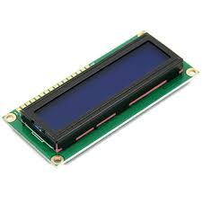

* Jumper wires (M-F, M-M each 10 pcs).

Jumper cables is a smaller and more bendable corrugated cable which is used to connect antennas and other components to network cabling.

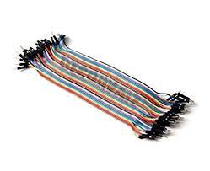

* Buzzer:

A buzzer or beeper is an audio signaling device, which may be mechanical, electromechanical, or piezoelectric. Typical uses of buzzers and beepers include alarm devices, timers, train and confirmation of user input.

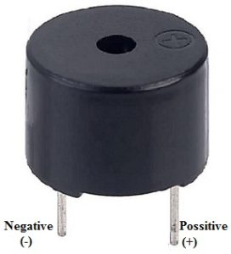

* Arduino IDE (Software Requirements)

The Arduino Integrated Development Environment - or Arduino Software (IDE) - contains a text editor for writing code, a message area, a text console, a toolbar with buttons for common functions and a series of menus. It connects to the Arduino hardware to upload programs and communicate with them.

|  |  |  |
| --- | --- | --- |
| **Hardware** | **Quantity** | **Price** |
| Arduino UNO | 1 | Rs.600 /- |
| HC-SR04 Ultrasonic sensor | 1 | Rs.90 /- |
| 16 x 2 LCD display. | 1 | Rs.130 /- |
| Jumper wires | 25 | Rs.50 /- |
| Buzzer | 1 | Rs.15/- |
| **Total** |  | **Rs.885 /-** |

### Principle and Working of project

### Step 1 Identify Components:

Firstly, identify components.

1. Arduino board (Arduino Uno)
2. Ultrasonic sensor (HC-SR04)
3. Liquid crystal display (LCD)
4. Connecting wires and breadboard for prototyping

### Step 2 Hardware Setup:

1. Connect the ultrasonic sensor to the Arduino board according to the sensor's datasheet or pinout.
2. Connect the LCD display to the Arduino for displaying the IV drip rate and any alerts.

**Step 3** Sensor Calibration:

Calibrate the ultrasonic sensor by measuring the flow rate of known quantities of liquid (e.g., water) and correlating it with the sensor's output.

**Step 4** Code:

Write Arduino code to read the flow rate sensor data and calculate the drip rate based on the sensor readings.

**Code:**

#include <Wire.h>

#include <LiquidCrystal_I2C.h>

LiquidCrystal_I2C lcd(0x27,16,2); // set the LCD address to 0x27 for a 16 chars and 2 line display

const int trigger = 5;

const int ecco = 4;

const int buzzerPin = 6; // Define the buzzer pin

void setup() {

lcd.init(); // initialize the lcd

lcd.init();

lcd.backlight();

pinMode(trigger, OUTPUT);

pinMode(ecco, INPUT);

pinMode(buzzerPin, OUTPUT); // Set the buzzer pin as an output

Serial.begin(9600);

lcd.setCursor(0,0);

lcd.print(" Depth level= ");

}

void loop() {

long duration, distance;

digitalWrite(trigger, LOW);

delayMicroseconds(30);

digitalWrite(trigger, HIGH);

delayMicroseconds(10);

digitalWrite(trigger, LOW);

duration = pulseIn(ecco, HIGH);

distance = 0.034 * duration / 2;

Serial.print("Object is at ");

Serial.print(distance);

Serial.println(" cm");

lcd.setCursor(5,1);

lcd.print(" ");

lcd.setCursor(5,1);

lcd.print(distance);

// Check if the distance is maximum (adjust the threshold as needed)

if (distance >= max_distance) {

// Activate the buzzer

digitalWrite(buzzerPin, HIGH);

delay(500); // Buzz for 500 milliseconds

digitalWrite(buzzerPin, LOW);

}

delay(1500);

}

## CHAPTER 7

## Conclusion

The implementation of an IV drip monitoring system represents a significant advancement in healthcare technology, offering unparalleled benefits in patient safety, treatment accuracy, and workflow efficiency. By automating the control and monitoring of intravenous fluid delivery, these systems minimize the risk of human errors, ensuring precise and consistent administration of medications, fluids, and nutrients. Real-time monitoring capabilities enable prompt detection and response to changes in infusion parameters, enhancing patient outcomes and reducing the likelihood of adverse events. Overall, IV drip monitoring systems play a crucial role in optimizing patient care delivery, fostering a culture of safety, and advancing the standard of care in healthcare settings.

## 

## CHAPTER 8

## Future Scope

The future scope for this project can be the integration of remote monitoring capabilities facilitates telemedicine initiatives and expands access to healthcare services, while comprehensive data collection and analysis support informed clinical decision-making and continuous quality improvement efforts. We can also use GSM to have alerts on the mobile phone using GSM Bluetooth technology. With enhancement and advancement of technology we would be able to predict the changes much more accurately and at a faster speed. We can also incorporate AI predictions for personalized treatments.

## References

1. <https://www.ee.iitb.ac.in/~spilab/Publicatios/bio_vision01_kamble_drip_rate.pdf>
2. https://www.ijraset.com/research-paper/iv-drip-monitoring-and-control-system/
3. <https://www.youtube.com/watch?v=wssqDE2wf9o>
4. https://youtu.be/Ee6s_Oe2dFY?si=gZRyesTElrVn1Exa
5. <https://youtu.be/DC3n1K5aVfM?si=8nVmy-dmNNuef7bg>
6. https://arduinogetstarted.com/tutorials/arduino-ultrasonic-sensor-piezo-buzzer